Creating a Public Amazon S3 Bucket

Objectives :-
After completing this lab, you will know how to:
- Create a bucket in Amazon S3
- Add an object to a bucket
- Manage access permissions on an object and a bucket
- Create a bucket policy
- Use bucket versioning

Step 1: Navigate to Amazon S3
- Log in to the AWS Management Console.
- In the search bar, type S3 and select Amazon S3 from the results.
- Click Create bucket on the S3 landing page to begin.
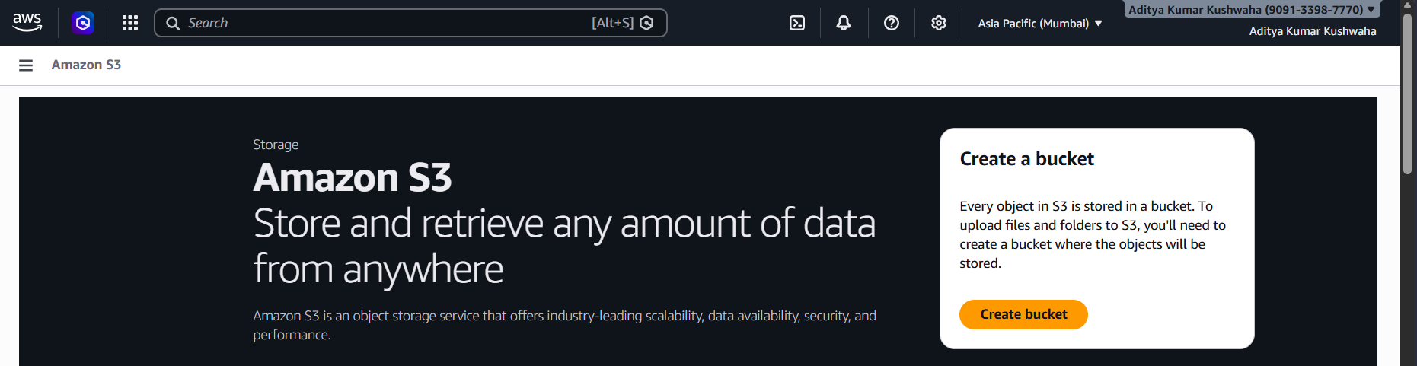

Step 2: Configure Bucket Name and Object Ownership (ACLs)
On the Create bucket page, configure the following:
- Bucket type: Select General purpose.
- Bucket name: Enter aws-ad-service.
- Under Object Ownership, select ACLs enabled and choose Object writer.
Note: ACL stands for Access Control List. Enabling ACLs is required to make individual objects public.
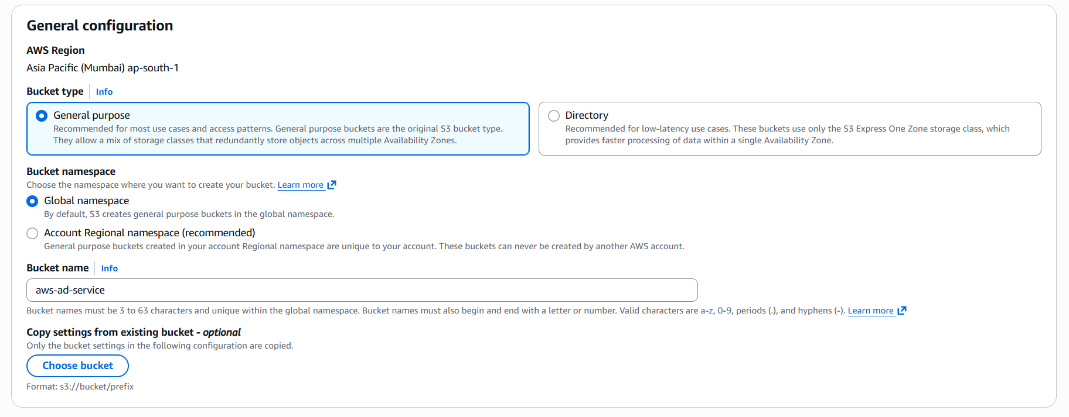

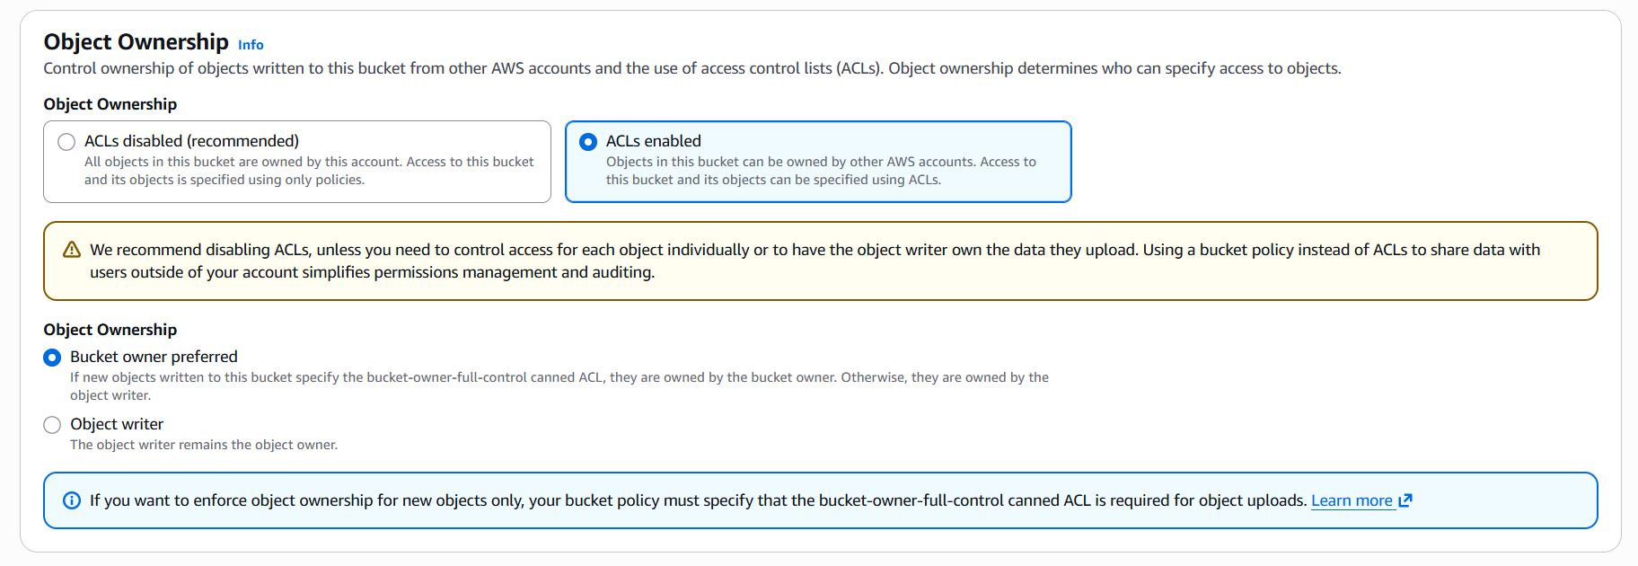

Step 3: Disable Block Public Access
To allow public access to the bucket:
- Uncheck the Block all public access option.
- Acknowledge the warning that the bucket and its contents may become publicly accessible.

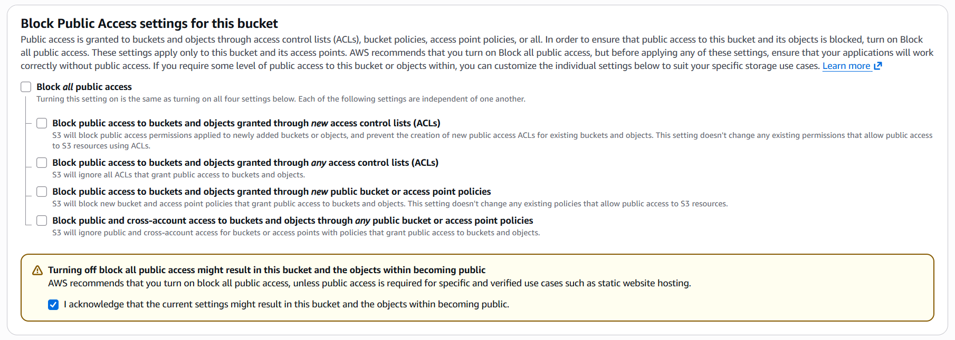
Step 4: Configure Default Encryption
Scroll to the Default encryption section:
- Enable server-side encryption (SSE-S3) to secure stored data.
- Review all settings and click Create bucket to finalize.

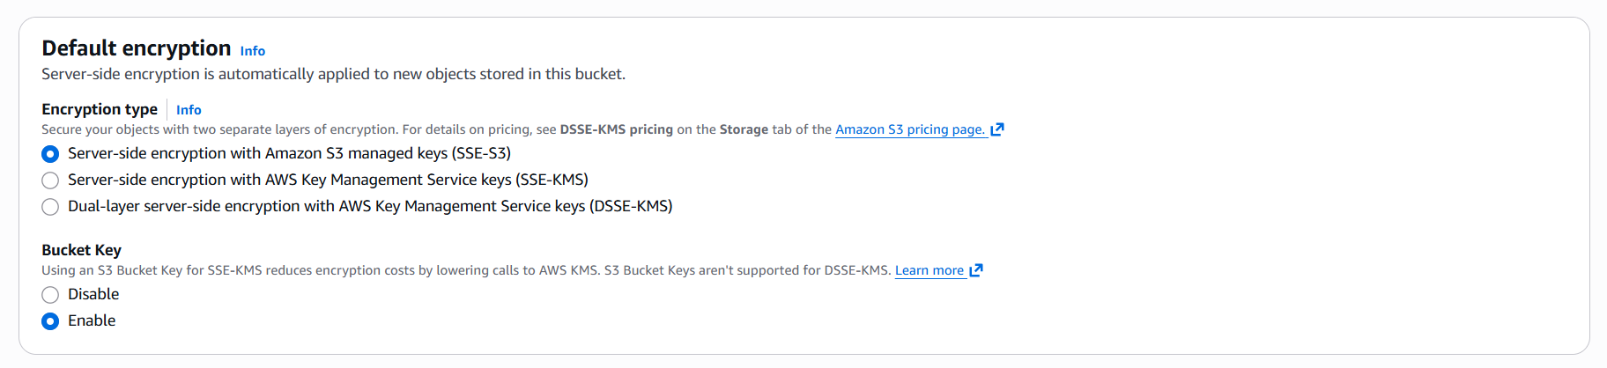

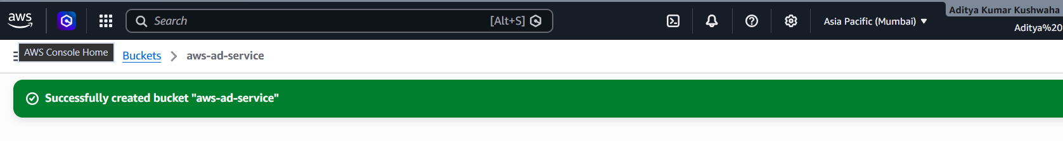

Step 5: The Bucket's Dashboard
After creating the bucket, open aws-ad-service in Amazon S3. You will be directed to its dashboard, where you can view and manage files, permissions, and settings.

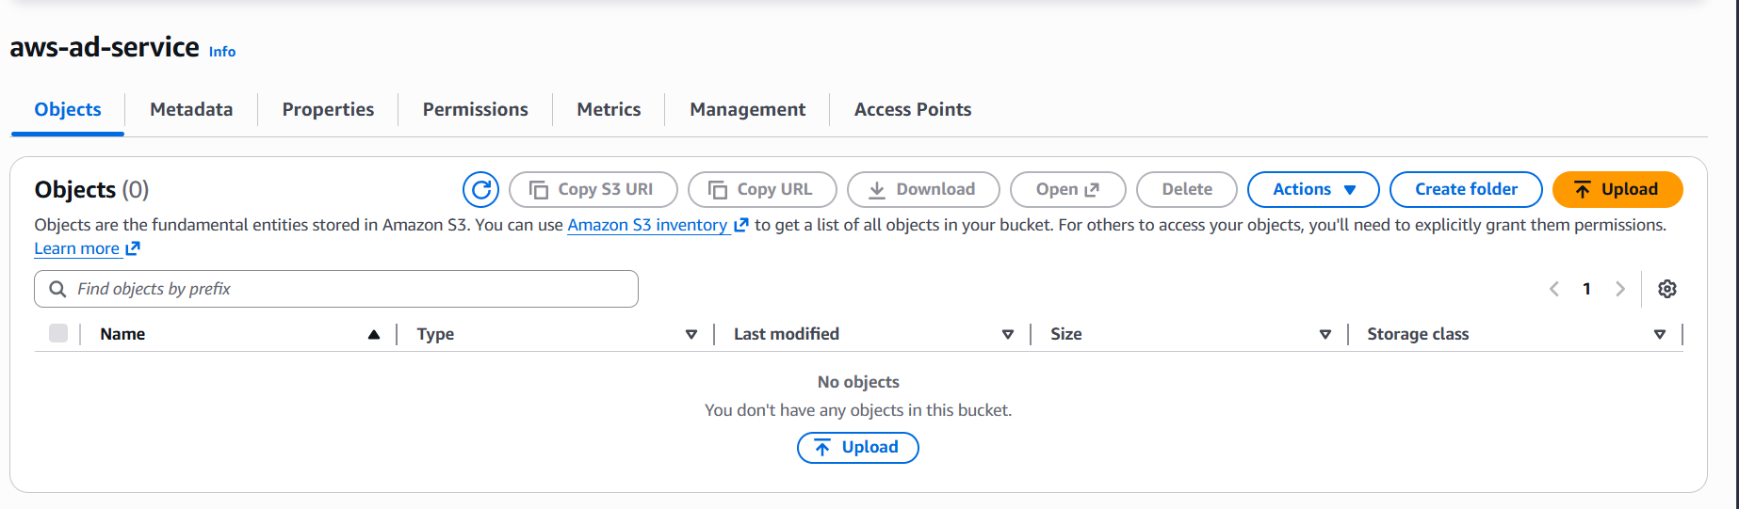

Step 6: Upload a File
Inside the aws-ad-service bucket in Amazon S3:
- Click on Upload.
- Select the file from your system and click Upload to add it to the bucket.

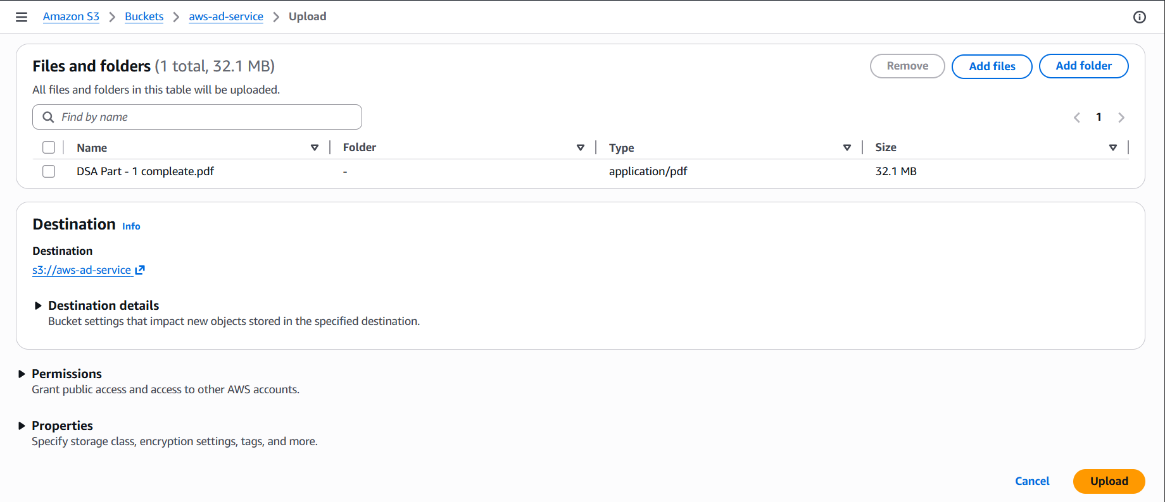

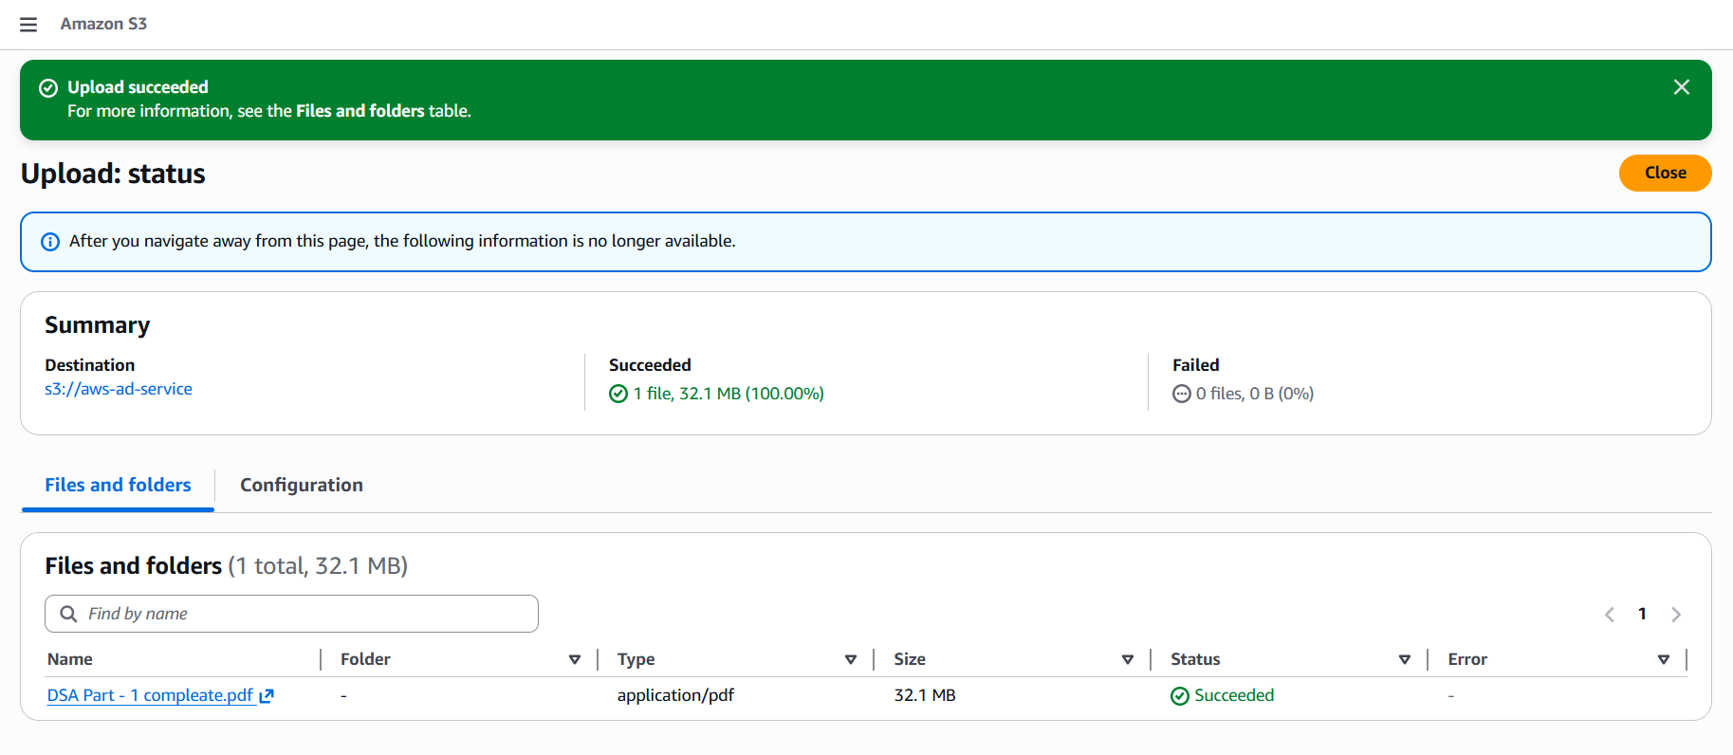

Step 7: The Object's Dashboard
In the aws-ad-service bucket, click on the uploaded file to open its object dashboard, where you can view details and manage the file.

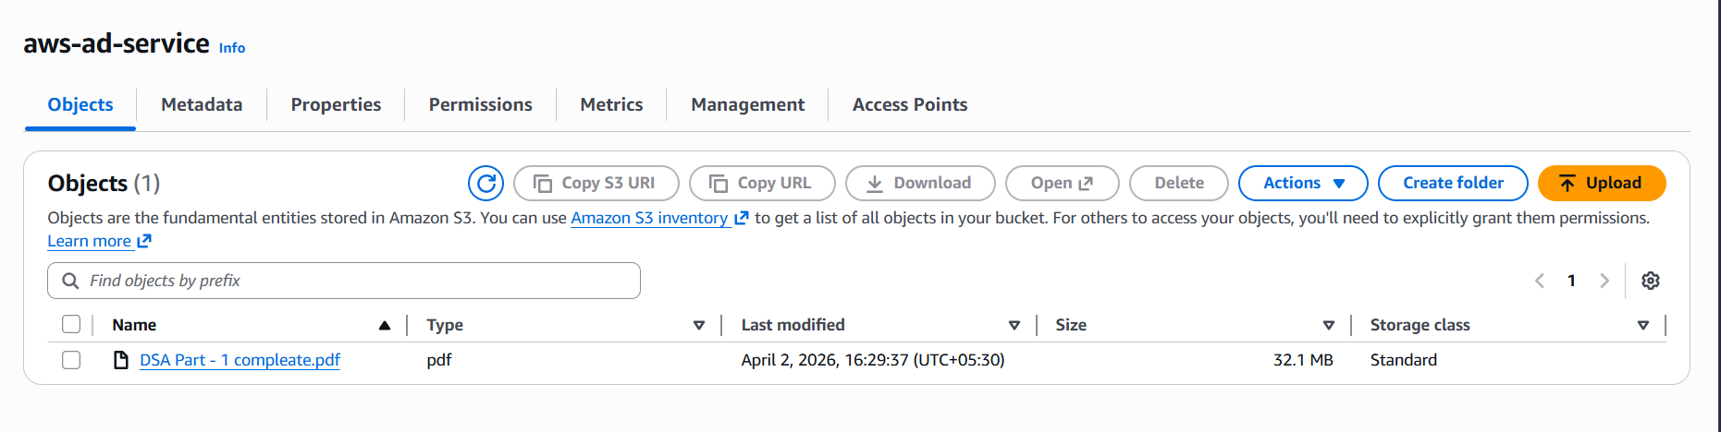
Step 8: Making the Object Public using ACL
In the object dashboard of your file in Amazon S3:
- Go to the Permissions tab.
- Under Access Control List (ACL), click Edit.
- Enable Read access for Everyone (public access).
- Save changes. The object is now publicly accessible via its URL link.

